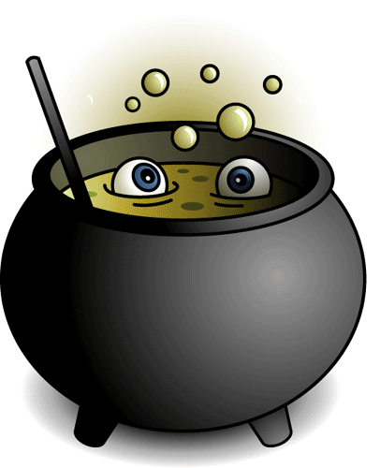

|  |  |  |  |  |
| --- | --- | --- | --- | --- |
| **1** | **cat** | **bat** | **spider** | **bee** |
| **2** | **witch** | **teacher** | **ghost** | **Dracula** |
| **3** | **spooky** | **creepy** | **happy** | **eerie** |
| **4** | **apples** | **candy** | **sweets** | **beef** |
| **5** | **cats** | **worms** | **toads** | **snails** |
| **6** | **broom** | **cat** | **cauldron** | **tv** |
| **7** | **black** | **orange** | **blue** | **purple** |
| **8** | **boo** | **pumpkin** | **party** | **potion** |
| **9** | **hoot** | **howl** | **boo** | **sing** |
| **10** | **vampire** | **ogre** | **monster** | **mummy** |
| **11** | **owl** | **zombie** | **werewolf** | **vampire** |
| **12** | **skeleton** | **skull** | **brain** | **bone** |

You see four words in each line. One word doesn’t go with the rest for some reason. You have to spot the odd one and highlight. There can be different reasons.

E.g.

Tooth – finger- foot –face (Here tooth is odd; the three other words begin with an F!

E

**ENGLISH** Y3 Beginners